Final Project Outline by Week – Stacey and Brooke

***Notes: Proposal.qmd is referenced in final project instructions. QMD is a Quarto file (download Quarto). I use ~~VSCode (Quarto extension is available to install) as a preference.~~ I am assuming this is what it is supposed to be called when it is opened in Quarto. Stacey download RStudio – watch lectures.

Download link for Quarto: <https://quarto.org/docs/get-started/>

Brooke will do - Each project will have our own repository (this is example): <https://info-526-su24.github.io/project-01/>.

***Instructions on how to create our own is in the shared folder. I still need to join the HW00 Github first.

Folders and files for each repository:

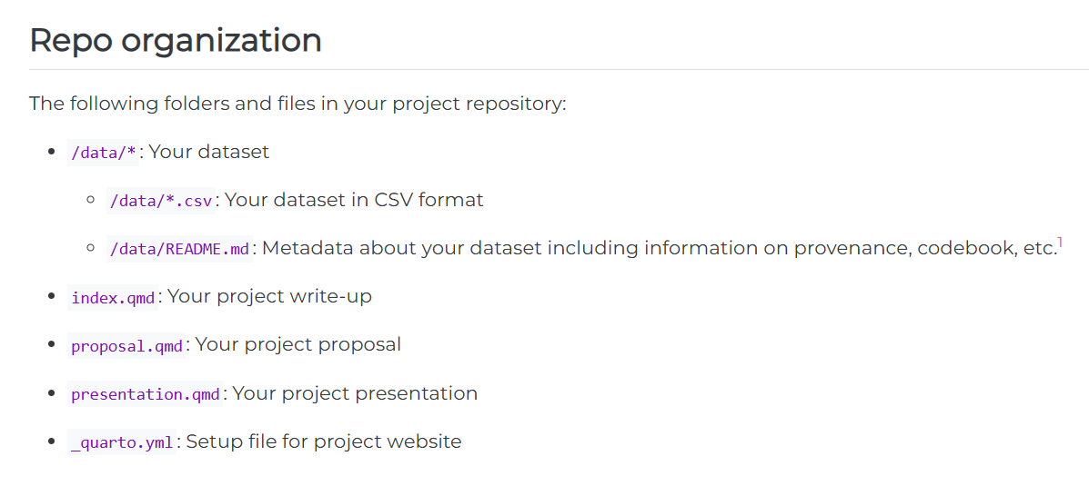

Week 1 – passed, need to play catch up.

***Week of May 19th (today is June 3rd) – Choose a dataset and begin writing your proposal in proposal.qmd.

Week 2 – passed, need to play catch up.

***Week of May 26th (today is June 3rd) – Continue working on your proposal in proposal.qmd.

__________________________________________________________________________________________

Week 3: ***Week of June 2nd – Provide a peer review to two other teams in the form of issues in their GitHub repos, address the issues left on your teams’ project repo by closing them with explicit comments. Feel free to get started on your presentation as well.

* Action item 1: Create repository
* Action item 2: Create proposal.qmd file
* Action item 3: Write the proposal – we will need to post by Wednesday at least for review from classmates over the weekend before Week 4 review from Professor Chism.
* Action item 4: Complete form for Professor Chism (website link: https://forms.gle/7BEZtu84qgXZjaoF6)

Week 4: ***Week of June 9th – Review feedback from Professor Chism on your proposal and close and remaining issues. Work on your presentation in presentation.qmd and writeup an index.qmd.

Week 5: ***Week of 16th, 23rd – Work on Project

Week 6: ***Week of June 30th – Finalize your write-up, presentation, and your project website. Record presentation for class by Monday (June 30th).

Due Dates

Proposal for peer review – Wednesday, June 4th

Revised proposals for teaching team review – Monday, June 9th at 1700 hours

Write-up and presentation – Monday, June 30th

Week 7